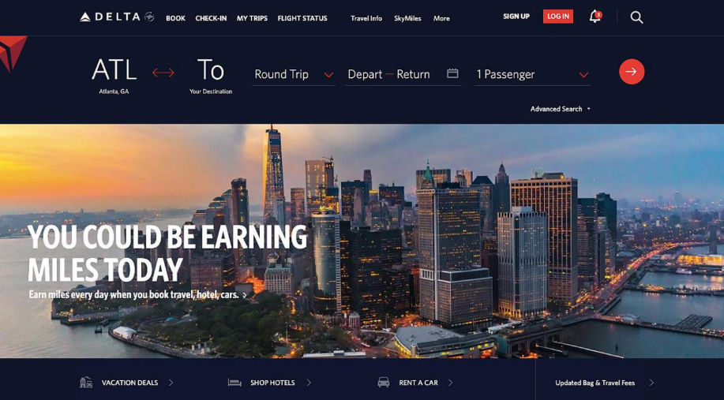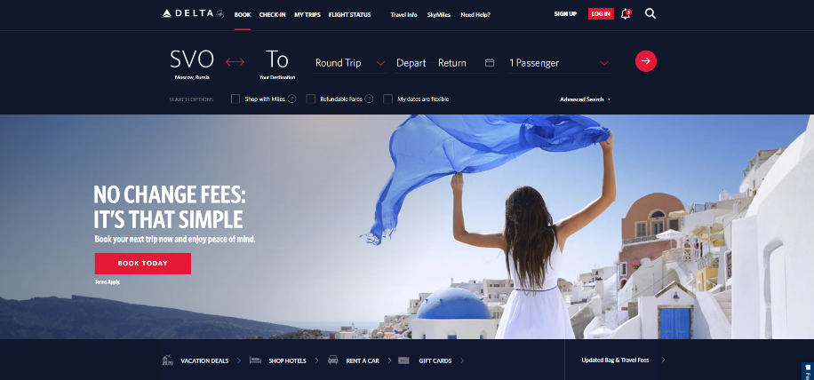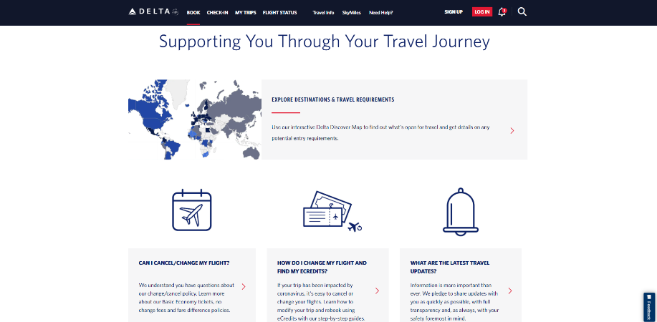

<https://www.delta.com/>

this website is popular travelling service website .

This website was built with PHP, Angular and Java EE.

I design dashboard front and developed Angular API in this project with senior front end developers